Lab #9 – Matt Cunningham
Digital Electronics
Combinational Logic Circuit – Number Detector

Objectives:
- To design a functional number detection circuit. It will read 4-bit BCD inputs and will output high when the inputs equal 3, 5 or 9 in decimal. Only valid BCD inputs will be applied to the circuit. The circuit will be created used VHDL. The overall objective is to apply what we have learned of VHDL and combine it with the basics of circuit design (Truth tables, K-maps, Boolean expressions) to make it functional on the DE10 board.
Equipment Used:
- Quartus 18.1 Software with ModelSim
- DE10 board
Procedure:
- Produce a truth table of inputs A, B, C, and D (these represent each bit of BCD). When any of these BCD combinations equal a decimal value of 3, 5 or 9, output will be high. BCD Inputs equalling any digit above 10 will output a don’t care.
- Design a K-Map that presents the high, low, and don’t care outputs based on the inputs of the truth table.
- In the K-map, group the common terms
- Using the groups made in the K-map, create a reduced Boolean expression Y
- With expression Y, write the VHDL code to generate the circuit
- Run the simulation of the code to confirm the generated circuit is correct to the expression
- Run a simulation of the circuit using ModelSim
- Use pin programmer to assign pins to the DE10 board
- Connect and program the DE10
- Test results on DE10 by putting the switches in all possible orientations from the reduced expression and confirming that the results are correct.
- Screenshot all major steps of the procedure (Truth table, K-maps, Boolean expressions, VHDL code, circuit design, simulation) and add to report
- Take images of various confirmed states of logic on DE10 board and add to report
Results:
I showed my professor the functional logic on the DE10 board. Below are all steps I took to build the functional program:
- I created the truth table, grouped K-map, and result Boolean expression
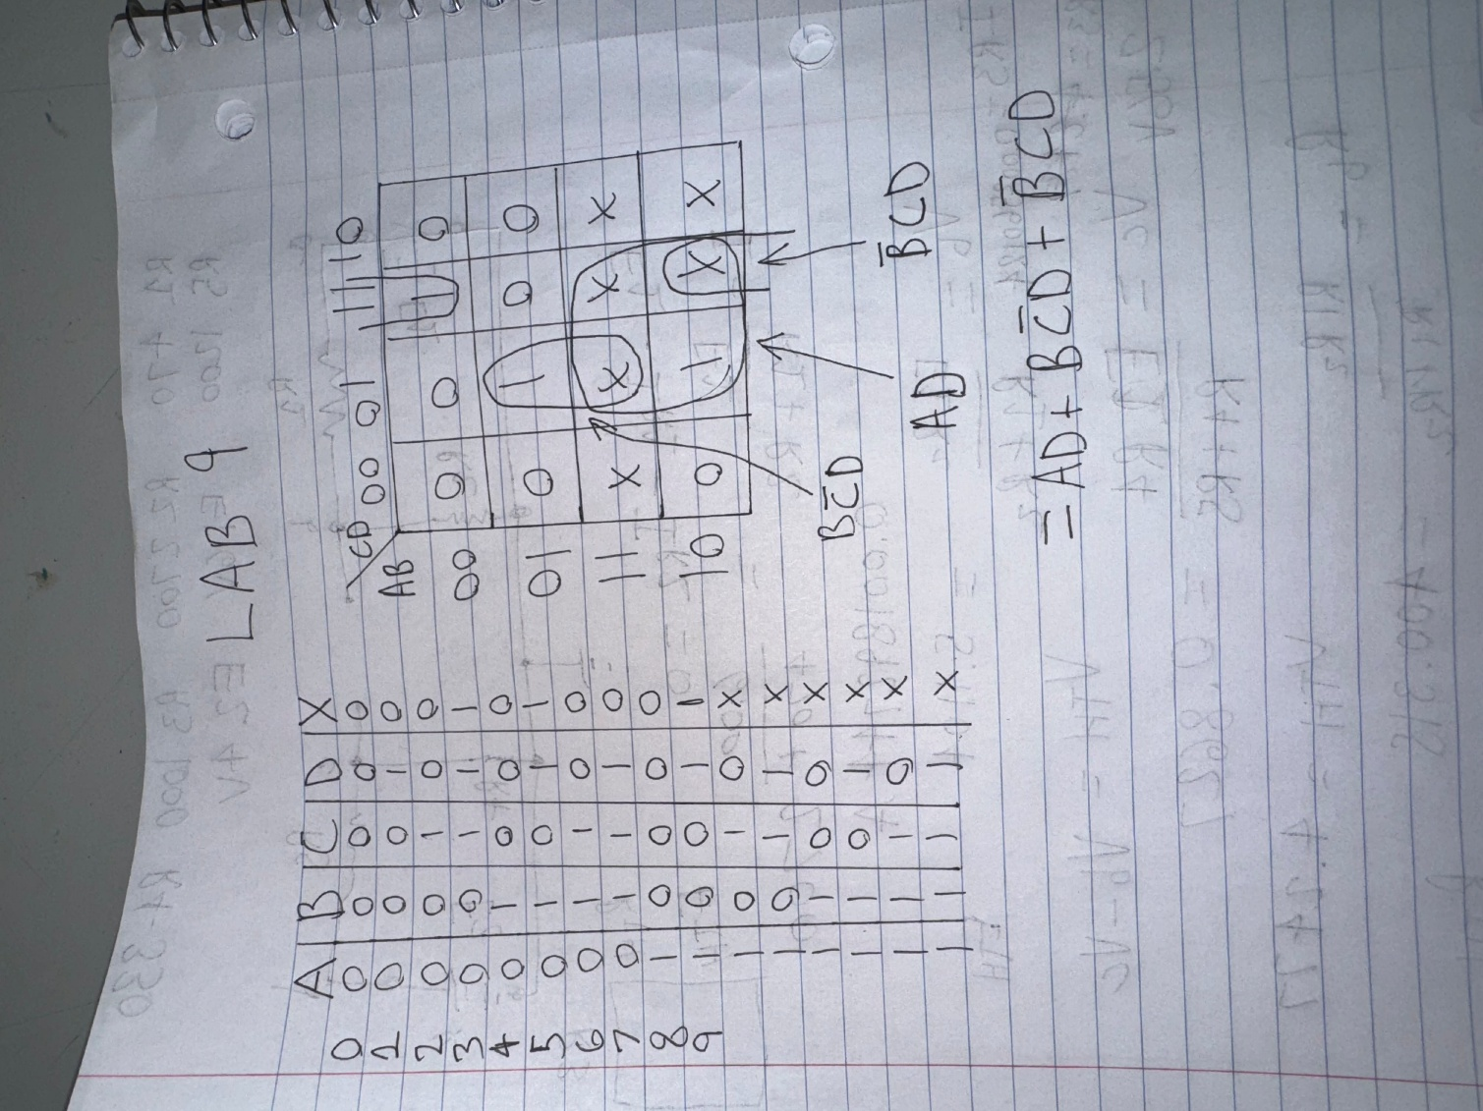

- I wrote the VHDL code to produce the circuit and ran the circuit simulation:
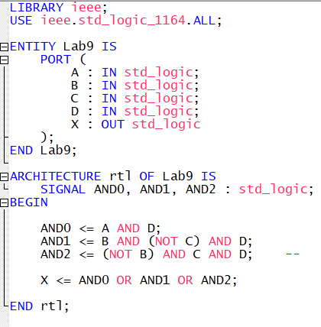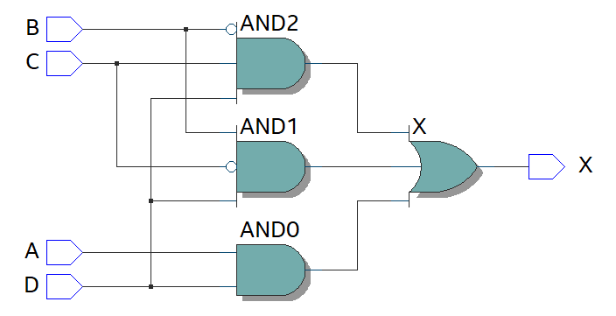

- I ran the ModelSim simulation to produce the timing diagram:
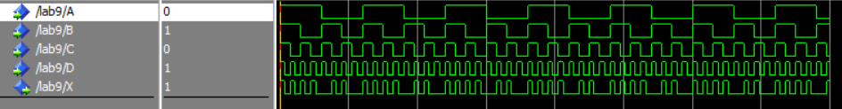

- I set the PINOUT in Pin Programmer
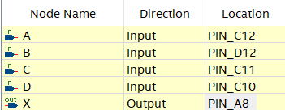

- Finally I connected the DE10 board and tested the results:
0 3 5
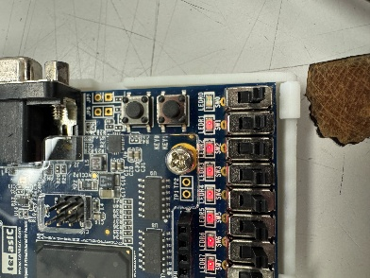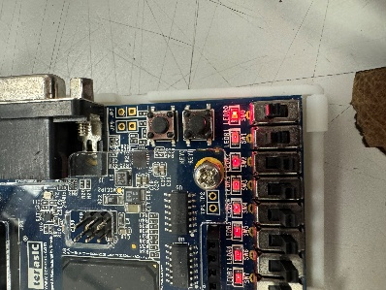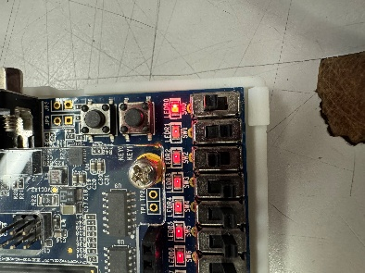
9
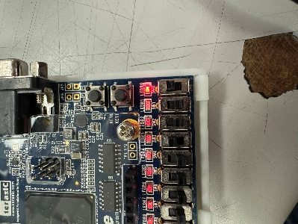

Conclusion:
It can be concluded that we have proven that VHDL code can be used to create equivalent circuits, the same way that block diagrams would create those circuits. All in all, the process is the same, however VHDL vs Block Diagrams each have their pros and cons for circuit design. For example, VHDL may allow quicker creation of circuits, but block diagram files may be easier to visualize while creating.

